CSIT115 L3

Graphical Notations for Conceptual Modeling

Entity-Relationship (ER) diagrams (1976)

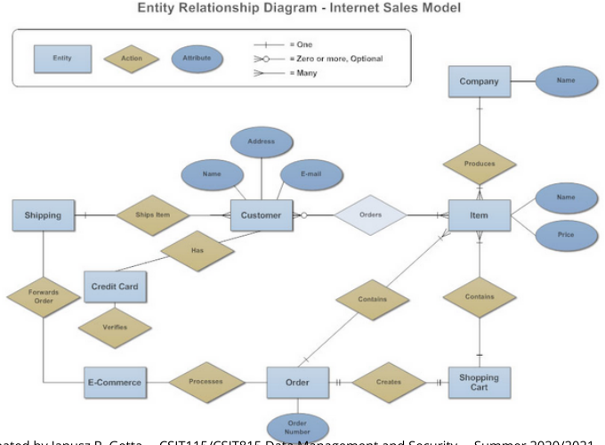

Object Modelling Technique (OMT) diagrams (1991)

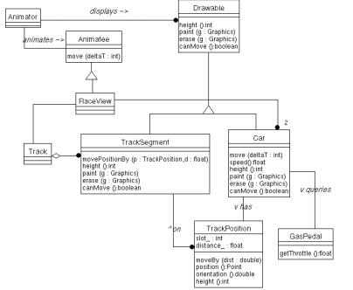

(Simplified) Unified Modelling Language (UML) Object Class diagrams (1994)

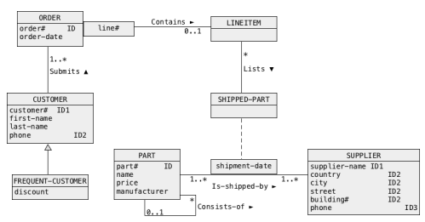

Object Role Modeling (ORM) diagrams

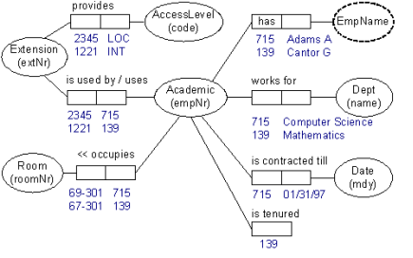

(Simplified) Class of Objects

A database suppose to contain information about people

A rectangular box with a header and a name of class (PERSON) inside a header represents a (simplified) class of objects

A person is described by a social security number, name, date of birth and address

The names of attributes are listed within a rectangular box one name of attribute per row

A person has from one to five email addresses and zero or more phone numbers

Multiplicity of attribute like [1..5] (from one to five), zero or more ([\*]or [0..\*]), one or more ([1..\*]), optional (zero or one, [0..1]), from "m" to "n" ([m..n]) follows a name of attribute

Default multiplicity is "one" ([1])

A person is described by an optional country of origin and age (/ in front of attribute name age denotes a derived attribute)

A person is identified by a social security number and independently by a triple (name, date of birth, address)

Every class must have identifier

A tag IDx following a name of attribute means, that an attribute is an identifier

If the same tag (e.g. ID2) follows the names of several attributes then it means that an identifier consists of several attributes

If an identifier consists of several attributes then it means, that each object in a class is identified by a tuple of values of the attributes

An identifier which consists of several attributes is called as a composite identifier

A vehicle is described by a registration number, manufacturer, model, year when manufactured and optional fuel consumption

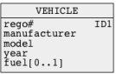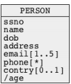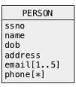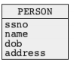Each vehicle has a different registration number

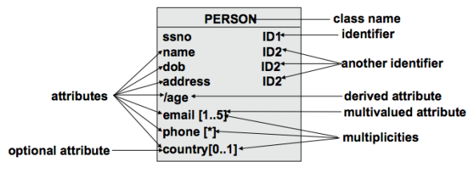

Association

A person owns a vehicle

A solid line that connects two classes represents an association

A name above a line is an association name

An association name if followed (preceeded or located above or below) by a small solid triangle, that represents a direction of interpretation of an association

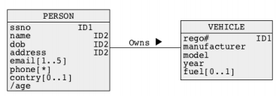

A vehicle has an owner

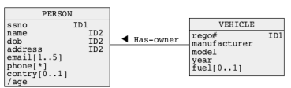

Locations of classes and associations in a diagram are immaterial

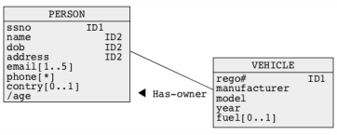

A person owns zero or more vehicles

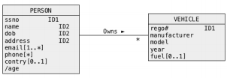

A vehicle has one owner

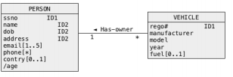

Multiplicities of association are located at both ends of a line that represents an association

One-to-one association

* A department has a manager
* A department has exactly one manager
* A person who is a manager manages exactly one department

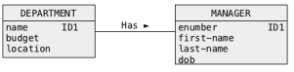

One-to-many association

* A company employs an employee
* A company employes many employees
* An employee works for none or one company
* It is possible that a company has no (zero) employees

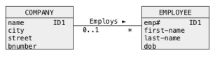

Many-to-many association

* A supplier supplies a part
* A supplier supplies zero or more parts
* A part is supplied by zero or more suppliers

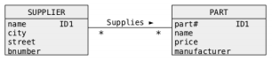

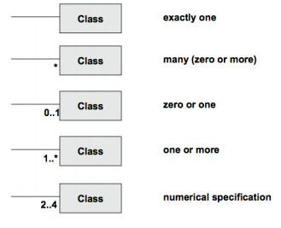

Link Attribute

A link attribute is an attribute that describes an association

A student enrols a subject

An enrolment is performed on a given day, it means, that an enrolment is described by an enrolment date

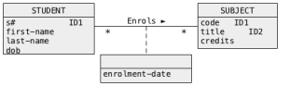

A link attribute is graphically represented by a "class-like" rectangular box without a name of class in a header

Why an attribute enrolment-date must be a represented by a link attribute ?

For example, what about an attribute enrolment-date describing a class STUDENT ?

Such design is incorrect because information about which subject has been enrolled by a student and on what date is missing

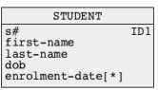A student is associated with a set of enrolment-dates, however, there is no link between the values of an attribute enrolment-date and the objects in a class SUBJECT

So what about another option where an attribute enrolment-date describes a class SUBJECT ?

Such design is also incorrect because information about who enrolled in a subject and on what date is missing again

A subject is associated with a set of enrolment-dates, however, there is no link between the values of an attribute enrolment-date and the objects in a class STUDENT

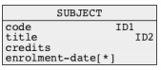Therefore, the only option for an attribute enrolment-date is to be a link attribute that describes an association between a class STUDENT and a class SUBJECT

If an attribute enrolment-date describes an association Enrols between the classes STUDENT and SUBJECT then its values are like labels attached to attached to the links between the objects from the classes STUDENT and SUBJECT

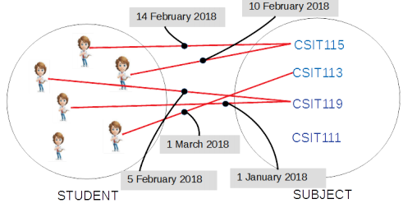

Association Class

An association class is a class that represents an association

A student enrols in a subject

An enrolment is performed on a given day, it means, that an enrolment is described by an attribute enrolment-date

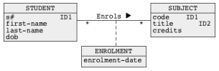

An association class ENROLMENT is graphically represented in the same way as a class of objects.

What about an identifier of an association class ?

An association class may have its own identifiers, for example enrolment-number in a class ENROLMENT

An association class that represents many-to-many association has a default identifier that consists of identifiers of the classes from both sides of association, for example a pair (snumber, code) in a class ENROLMENT

There is no need to include a default identifier into a description of a class of objects

Qualification

A building at a university campus is described by a unique number, optional name and the total number of floors

A room is described by a number and area

A building consists of rooms



What is an identifier of a class ROOM ?

Identifier of a class ROOM is a composite identifier and it consists of the attributes bnumber from a class BUILDING and rnumber from a class ROOM

How do we represent composite identifiers that consist of attributesfrom more than one class ?

We use a qualification !

Generalization

A generalization hierarchy represents Is-a-subset relation between the classes of objects

A set of all undergraduate students is a subset of a set of students, it means, that an undergraduate student IS-A student

A set of all postgraduate students is a subset of a set of students, it means, that a postgraduate student IS-A student

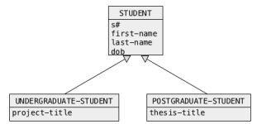

A generalization hierarchy is built with arrows pointing from a subclass to a superclass

Another graphical notation for generalization hierarchy:

A car IS-A vehicle and a truck IS-A vehicle

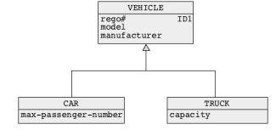

Entity-Relationship Modeling

Entity-Relationship Modeling is another graphical conceptual modelingnotation

It is presented in your texbook

Graphically it is very similar to Object Data Model

The following concepts from the notations are equivalent:

* Class of objects = Entity type
* Object = Entity instance
* Association = Relationship
* Identifier = Primary key or Candidate key
* Qualification = Weak entity type